Ideation Phase
Empathize & Discover

Date | 01 October 2026
Team ID | SWTID-2026-7653
Project Name | Script-Controlled ACL – Restrict Record Access Based on Field Value
Maximum Marks | 4 Marks

Empathy Map Canvas:
An empathy map is a simple, easy-to-digest visual that captures knowledge about a user’s behaviours and attitudes.

It is a useful tool to helps teams better understand their users.
Creating an effective solution requires understanding the true problem and the person who is experiencing it. The exercise of creating the map helps participants consider things from the user’s perspective along with his or her goals and challenges.

Reference: https://www.mural.co/templates/empathy-map-canvas

Project-specific Empathy Map: EEE User and ServiceNow Administrator
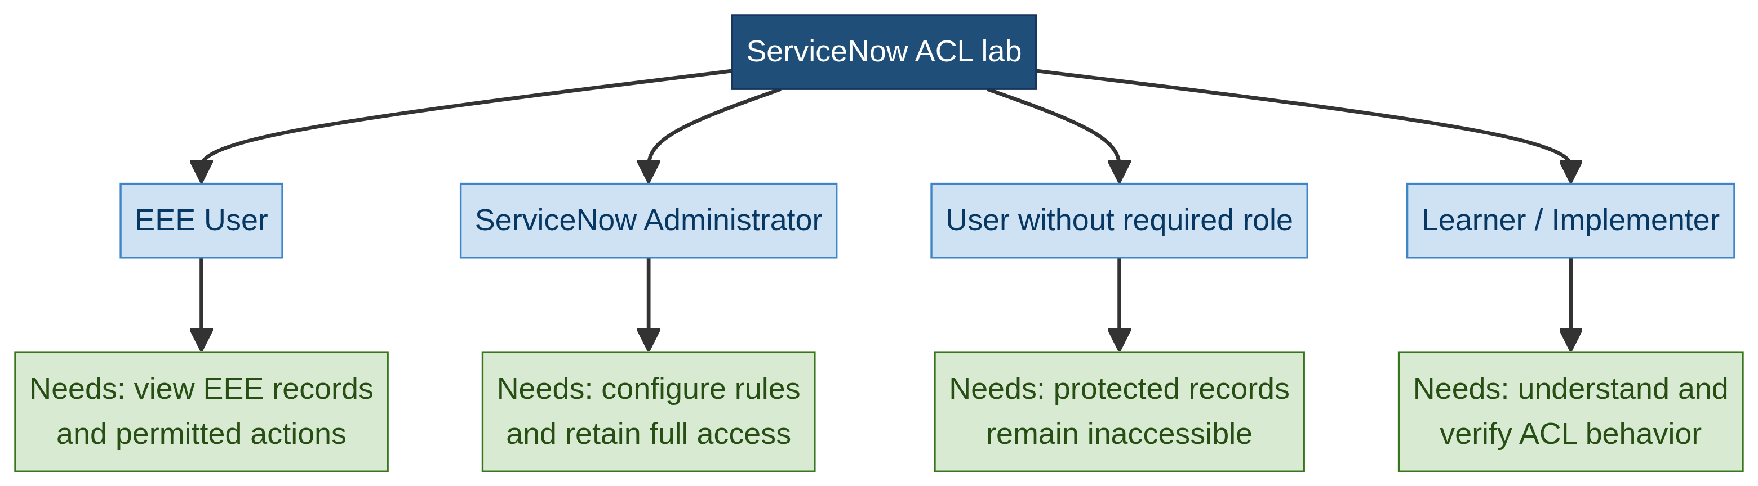
Project visual: stakeholders and needs implied by the ServiceNow ACL lab.
This map is derived from the workflow in the supplied project document. It represents implied stakeholders in the lab; it does not claim that external interviews were conducted.
Says | Thinks | Does | Feels
I need to access records relevant to the EEE branch.  I should only perform the actions my role permits. | Which records can I see?  Which role permits read, create, write or delete? | Signs in, opens the u_institution_details list, views EEE records and tests permitted actions. | Confident when access is correct; concerned or frustrated when records or actions are incorrectly exposed or denied.

Stakeholders and needs
Stakeholder | Need
ServiceNow administrator | Configure users, roles, tables, scripts and ACLs correctly; retain full access.
EEE User | View only EEE records and perform actions allowed by assigned roles.
User without required role | Be prevented from viewing or changing protected records.
Learner / implementer | Understand and verify how roles, data conditions and ACL scripts work together.

Key discoveries
• Branch is the record-level business condition: ECE, EEE and CSE must be distinguishable.
• Read, create, write and delete require separate security decisions.
• The administrator needs a full-access path for management and testing.
• Impersonation is needed to verify the experience of authorized, unauthorized and administrator users.
Visual note: The default example image from the original template was removed and replaced with a diagram based on the supplied ACL project.

